**Exercise 2: Verifying Interactions**

**Scenario:** You need to ensure that a method is called with specific arguments.

**Code:**

*ExternalApi.java –*

package com.example;

public interface ExternalApi {

String getData();

}

*MyService.java –*

package com.example;

public class MyService {

private ExternalApi api;

public MyService(ExternalApi api) {

this.api = api;

}

public String fetchData() {

return api.getData(); // Interaction that we will verify

}

}

*MyServiceTest.java –*

package com.example;

import static org.mockito.Mockito.*;

import org.junit.jupiter.api.Test;

import org.mockito.Mockito;

public class MyServiceTest {

*@Test*

public void testVerifyInteraction() {

// Step 1: Create mock

ExternalApi mockApi = Mockito.*mock*(ExternalApi.class);

// Step 2: Use mock in service

MyService service = new MyService(mockApi);

service.fetchData();

// Step 3: Verify interaction

*verify*(mockApi).getData();

}

}

*pom.xml –*

<project xmlns="http://maven.apache.org/POM/4.0.0" xmlns:xsi="http://www.w3.org/2001/XMLSchema-instance" xsi:schemaLocation="http://maven.apache.org/POM/4.0.0 https://maven.apache.org/xsd/maven-4.0.0.xsd">

<modelVersion>4.0.0</modelVersion>

<groupId>com.example</groupId>

<artifactId>mockito-demo2</artifactId>

<version>0.0.1-SNAPSHOT</version>

<dependencies>

<!-- JUnit 5 -->

<dependency>

<groupId>org.junit.jupiter</groupId>

<artifactId>junit-jupiter-api</artifactId>

<version>5.9.3</version>

<scope>test</scope>

</dependency>

<dependency>

<groupId>org.junit.jupiter</groupId>

<artifactId>junit-jupiter-engine</artifactId>

<version>5.9.3</version>

<scope>test</scope>

</dependency>

<!-- Mockito -->

<dependency>

<groupId>org.mockito</groupId>

<artifactId>mockito-core</artifactId>

<version>5.11.0</version>

<scope>test</scope>

</dependency>

</dependencies>

</project>

**Output: (Screenshots)**

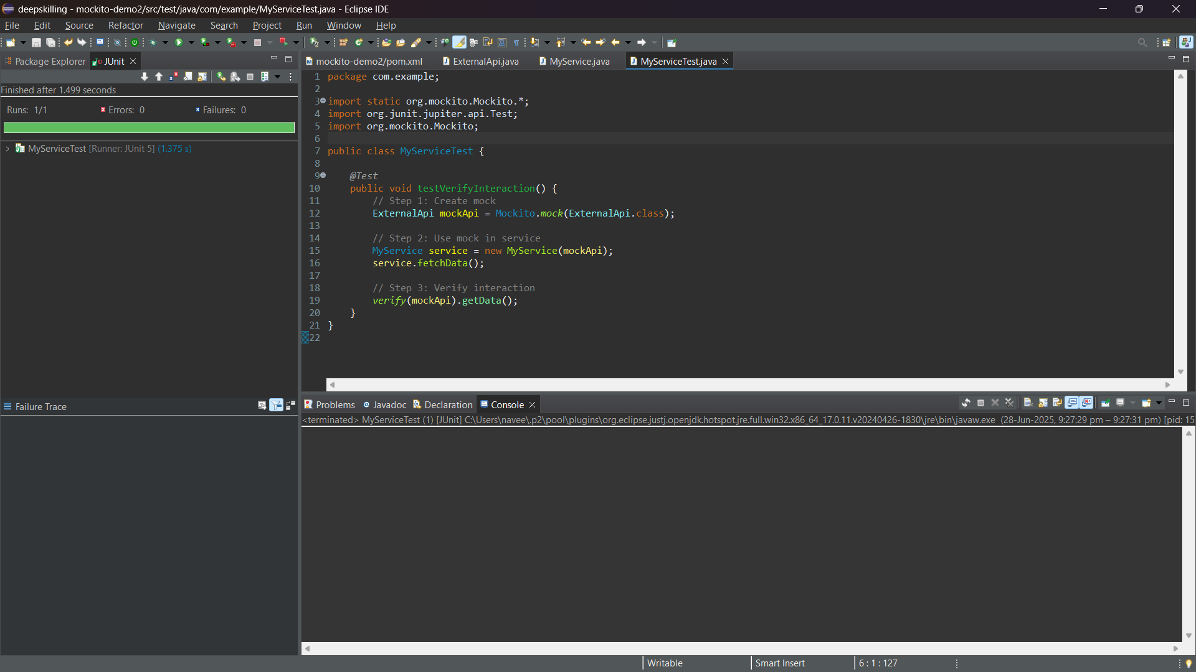

**Project Structure –**

